

**Faculty of engineering - Shoubra**

**Benha University**

**Research Project**

in fulfillment of the requirements of

|  |  |
| --- | --- |
| **Department** | **Engineering Mathematics and Physics** |
| **Division** | **-----------------** |
| **Academic Year** | **2019-2020 Preparatory** |
| **Course name** | **Computer** |
| **Course code** | **ECE006** |

**Title: -**

**Build a website on Database systems**

By:

|  |  |  |  |
| --- | --- | --- | --- |
|  | Name | Edu mail | B.N |
| 1 | محمد هشام سيد صالح | [muhammed195909@feng.bu.edu.eg](mailto:muhammed195909@feng.bu.edu.eg) | 817 |

**Approved by:**

|  |  |
| --- | --- |
| Examiners committee | Signature |
| Dr.Ahmed Bayoumi |  |
| Dr.Shady Elmashad |  |
| Dr. Abdelhamid Attaby |  |

**Table of contents**

|  |  |
| --- | --- |
| **Subject / section** | **Page** |
| Links | 1 |
| Application brief | 2 |
| Screenshots of Webpages | 4 |
| Screenshots of code sources | 9 |

**Links**

|  |  |
| --- | --- |
| **GitHub-link** | <https://github.com/muhamed-hesham/Database-Systems> |
| **GitHub-page (published webpage)** | <https://mohammedhesham315.github.io/ece001/> |

**Application brief**

Database is an organized collection of structured information, or data, typically stored electronically in a computer system. A database is usually controlled by a database management system (DBMS). Together, the data and the DBMS, along with the applications that are associated with them, are referred to as a database system, often shortened to just database.

**Fig.2**

**rt**

**Fig.4**

**Fig.6**

**Fig.8**

Some Types of Databases

Depending upon the usage requirements, there are following types of databases available in the market:

1. Centralized Database.
2. Distributed Database.
3. Commercial Database.
4. Relational Databases.
5. Object-Oriented Databases.
6. Graph Databases.

Applications of Database

* Banking.
* Airlines.
* Telecommunication.
* Manufacturing.
* Finance.
* HR Management.

Some Advantages of Database

- Reduced data redundancy.

- Reduced updating errors and increased consistency.

- Greater data integrity and independence from applications programs.

- Improved data access to users through use of host and query languages.

Some Disadvantages of Database

- Database systems are complex, difficult, and time-consuming to design.

- Substantial hardware and software start-up costs.

- Damage to database affects virtually all applications programs.

- Extensive conversion costs in moving form a file-based system to a database system.

Screenshots of Webpages

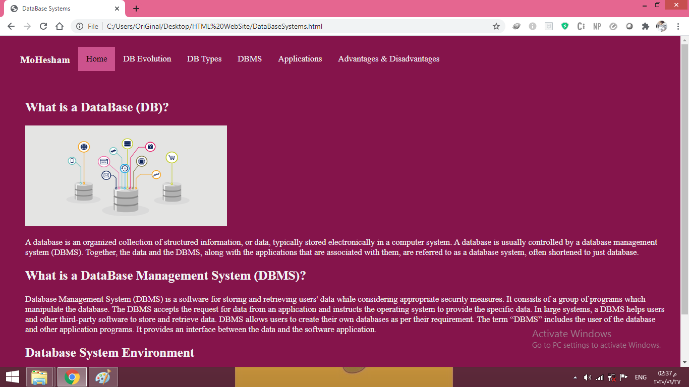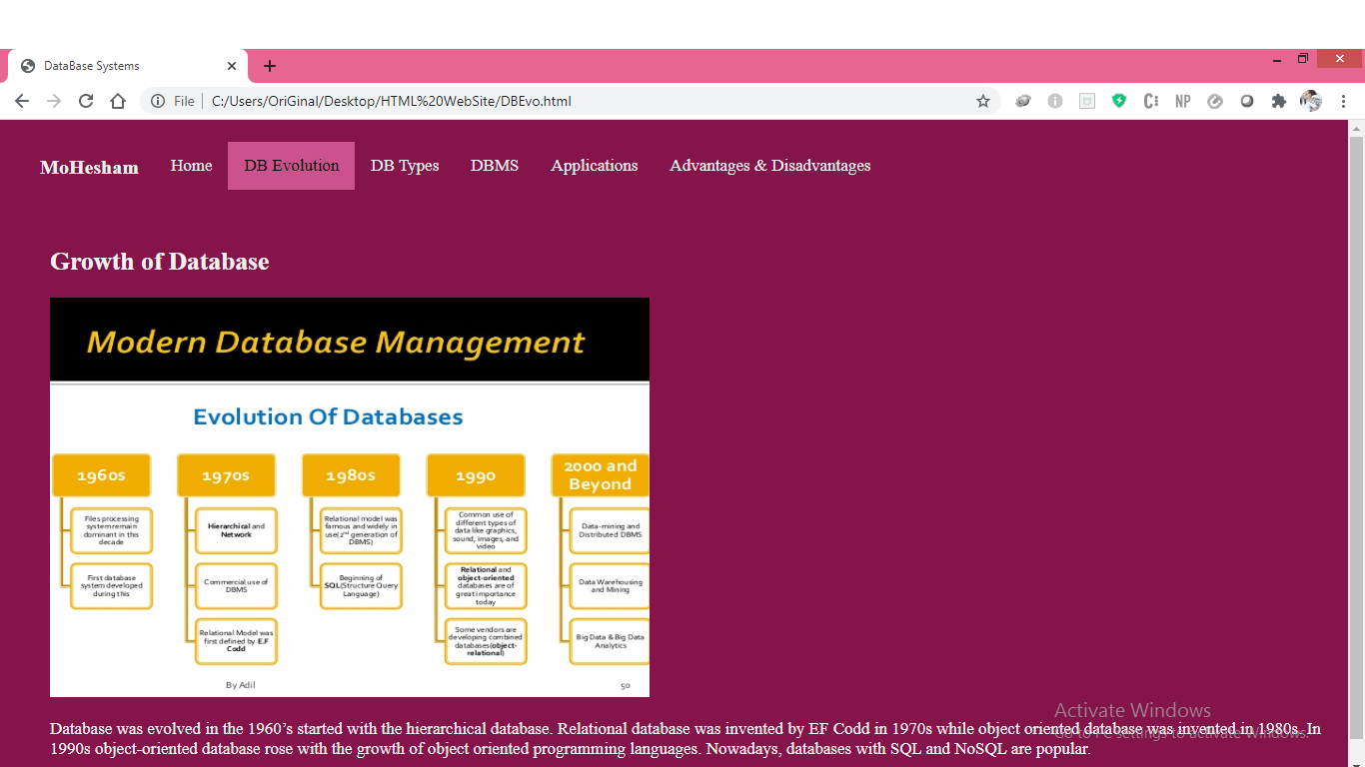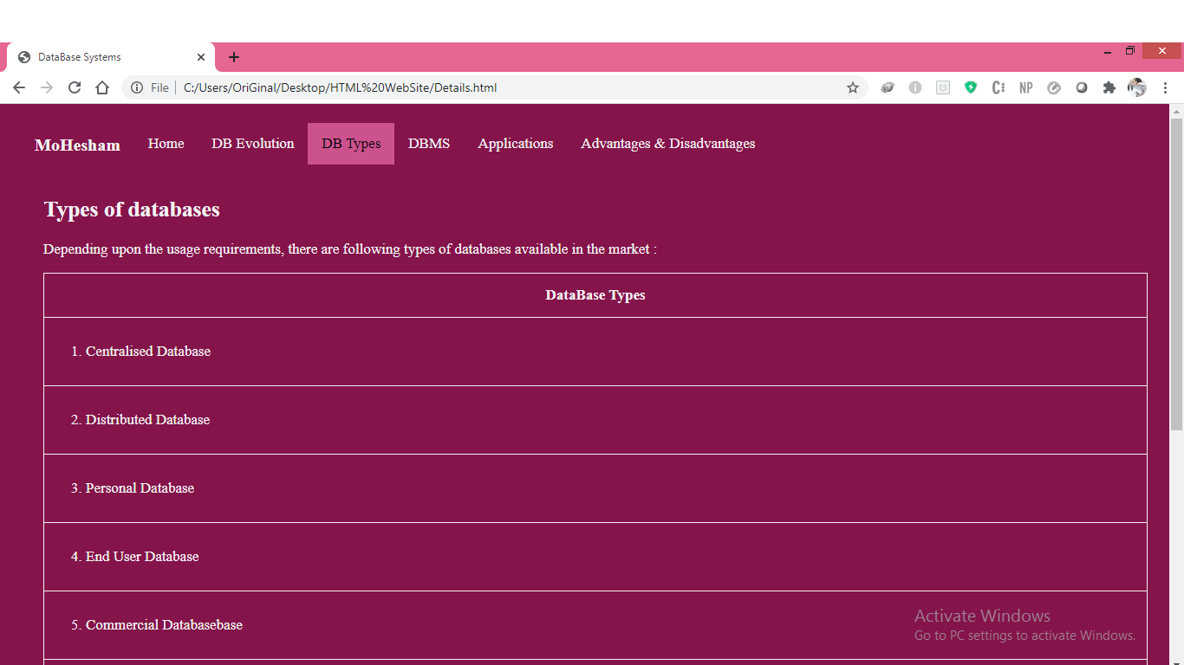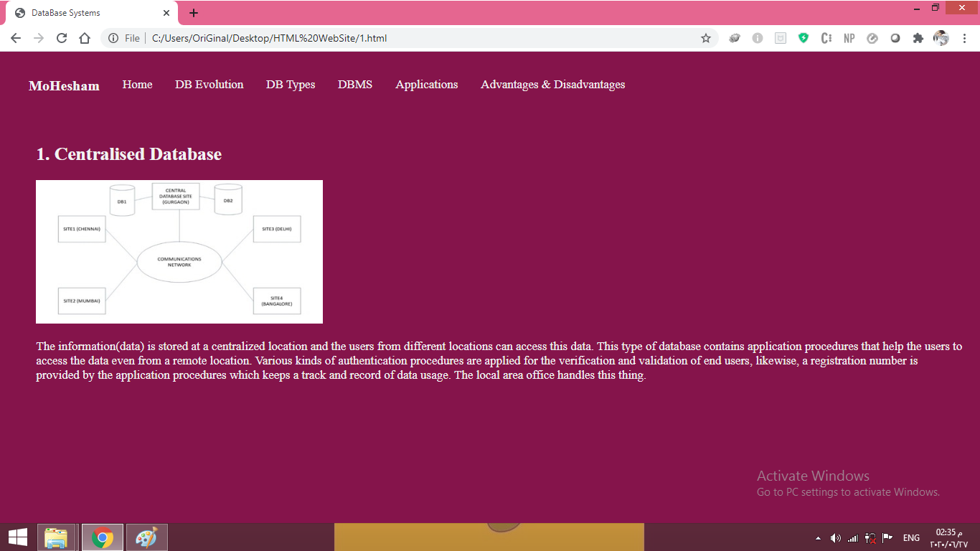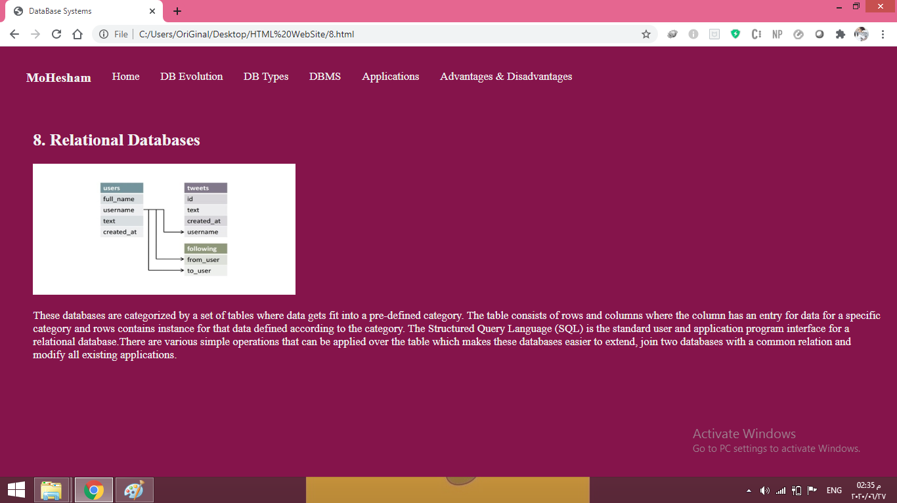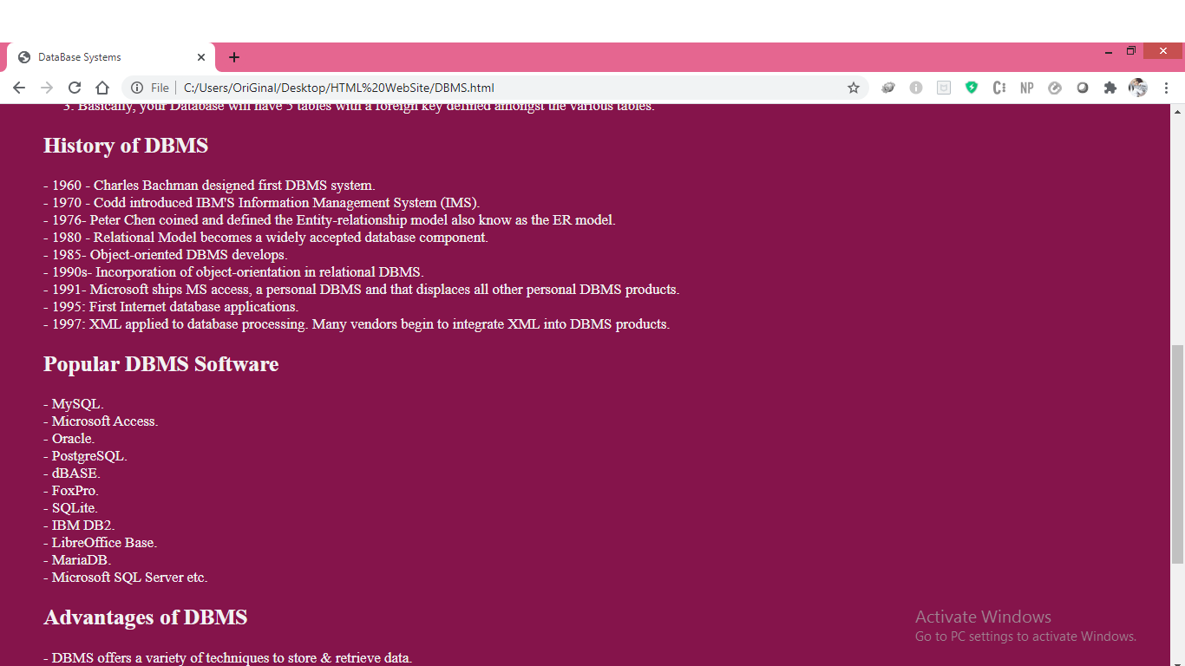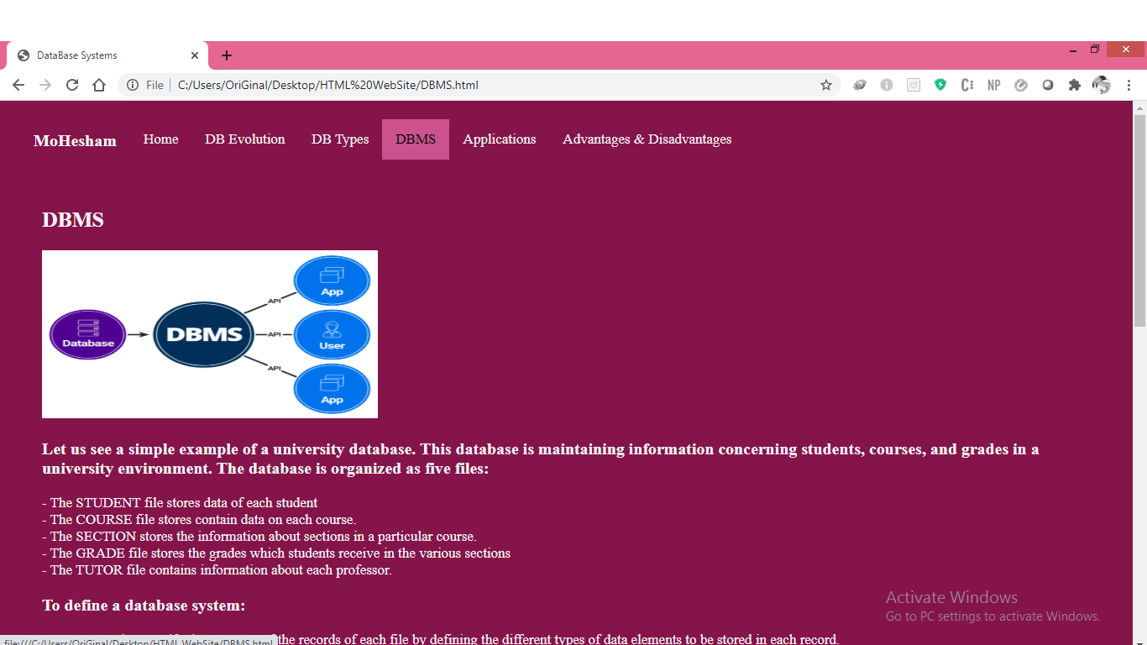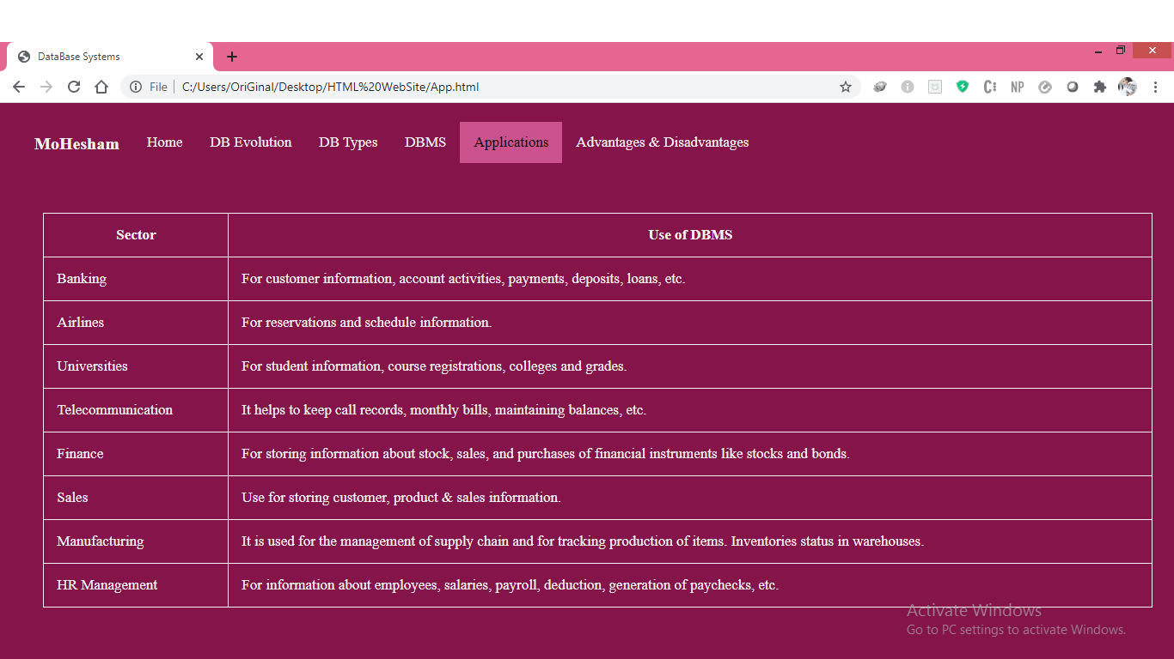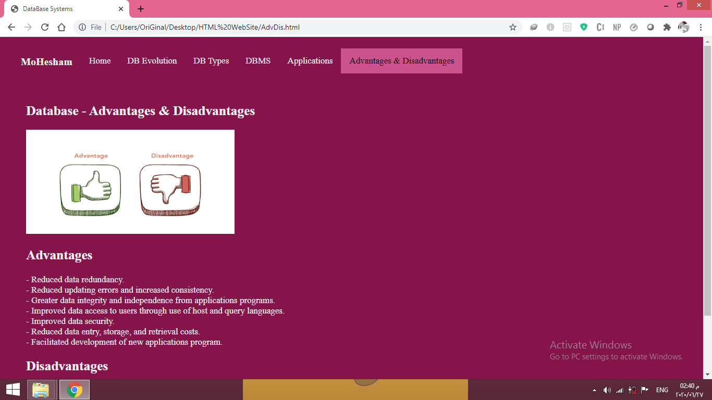

Screenshots of code sources

